|  |
| --- |
|  |
| Quiz app |
|  |
|  |
|  |
|  |

|  |
| --- |
| [Type the abstract of the document here. The abstract is typically a short summary of the contents of the document. Type the abstract of the document here. The abstract is typically a short summary of the contents of the document.] |

Table of Contents

ABSTRACT 3

Introduction 4

Problem Statement 5

Scope of the Project 5

Software Requirements 5

Project Requirements 5

Functional Requirements 5

Non-Functional Requirements 6

Planning and Methodology 8

Project Activities and Deliverables 8

Phase 1 9

Phase 2 9

Methodology 9

Project Diagrams 12

Data Flow Diagram: 12

Use case Diagram: 13

Sequence Diagram: 14

User Interface: 15

Figure 1 Project Activities. 8

Figure 2 Agile Development Methodology 10

Figure 3: Data Flow Diagram 11

Figure 4: Use case Diagram 12

Figure 5: Sequence Diagram 13

# ABSTRACT

The app created here is for the sake of preparation for general knowledge brain storming and providing a game play testing method for the students so that the students can test their skills and preparation of the test in the form of a game. This app provides the students with different levels of tests which student can unlock by passing one after the other and reaching the final one. Reaching the final one intended to be reached by passing all the important and necessary MCQ’s for the GENERAL KNOWLWDGE. Tests for all the subjects are available in the app students can set the difficulty level of the test accordingly and can view their test scores any time and can set target scores and challenging difficulties for making the study and testing more interesting as the basic purpose of making this application is to make the students way of preparation more interesting and interactive.

# Introduction

The app created here is for the sake of preparation of the general Knowledge preparation for students. And providing a game play testing method for the students so that the students can test their skills and preparation of the GENERAL KNOWLWDGE test in the form of a game. The student can download the app from the play store and then registering as a new user by adding the details and if already user login with the credentials. This play and learn GENERAL KNOWLWDGE app provide the students with different levels of tests which student can unlock by passing one after the other and reaching the final one. Reaching the final one intended to be reached by passing all the important and necessary MCQ’s for the GENERAL KNOWLWDGE. Tests for all the subjects are available in the app students can set the difficulty level of the test accordingly and can view their test scores any time and can set target scores and challenging difficulties for making the study and testing more interesting as the basic purpose of making this application is to make the students way of preparation more interesting and interactive.

# Problem Statement

The problem statement for making this interactive application is to teach the students in an interactive way so that their learning abilities can be enhanced, and for creating an ease of learning and scoring good in the GENERAL KNOWLWDGE by making the test preparation a game for the students. Passing every level in the game make the student confident on what he/she has learnt.

# Scope of the Project

The project scope includes the following stated highlights

1. User can view.
2. User can select quiz type.
3. Displaying the dashboard.
4. Student can check the scores.
5. Student can check the history.
6. Student can give the feedback.
7. Student can set the difficultly level in the settings.

# Software Requirements

The software used here in this project are stated as follows:

1. **Xamarine VS:** For the sake of the front-end development.

# Project Requirements

Every software project is comprised of two types of the requirements; these requirements are stated as follows:

1. Functional Requirements.
2. Non-Functional Requirements.

## Functional Requirements

Functional requirements are those which are fulfilled for the sake of the performance of the actual working of the project. The functional requirements for the E-test app are stated as follows:

**R.1 View Homepage**

* Adding user information.
* Saves user information to the database.

**R.2 Login**

* Verifies the user credentials.

**R.3 Dashboard**

* Show the available application options to the user.

**R.4 Start Test**

* Allows User to select the type and level of the test.

**R.5 Set Difficulty**

* Allow the user to set the difficulty level of the test.

**R.6 View Test Results**

* Allows user to view the test scores.

**R.7 Provide Feedback**

* Allows the user to report any problem in the app or changes suggestions in the app.

## Non-Functional Requirements

These are the type of the requirements that are not actually the need of the actual functionality of the project but are needed for the fluent working of the applications or software functionality. It explains the system aspects relevant to how the system meets the functional requirements. Following are some non-functional requirements of the system:

* The system shall allow the user to access the Application from the Android interface. The Android application will be used as an interface for the system. The special training is not required as the Application is user friendly and it is easy to use it.
* The Application should have the high level of performance when dealing with the customer input and should be able to response back to the customers feedback in short span of time.
* Errors should be handled in an appropriate way. Error rate should be minimized as much as it can be. There must be an appropriate error message for the customers. The time to recover from an error should also be as much less as it can be.
* The availability of the system should be any time anywhere so that customer can be able to use the system at the time, he wants it. If in case any malfunction occurs system should be recovered as soon as possible so that business is not severally affected by this.

System should be user friendly interface should be developed in a way that anyone with even less knowledge of system can use it

## Planning and Methodology

### Project Activities and Deliverables

Quiz app

Project

Management

Testing

Software

Development

Design

Analysis

Requirements

Gathering

FR’s

NFR’S

DB Implementations

GUI’s

Coding

Process Model Section

Data flow Model

UML Description

Class Diagrams

Test Case

Development

Work Breakdown Schedule

Managerial process plan

Figure 1 Project Activities.

The project **deliverables** are listed below:

1. Proposal Document
2. Abstract Document
3. Literature Review
4. Software Requirements Specification (SRS) document
   1. Useful and Non-useful functional Requirements
   2. Use cases and UML diagrams
   3. Context diagrams
   4. System Architecture Diagram
   5. Entity Relationship Diagram
5. Database Schema
6. User Interface Design Document

### Phase 1

Phase 1 of the project mainly comprised of the following activities:

* Problem identification
* Problem statement
* Review of related research work and existing solutions
* Requirements analysis and design
* Database design
* Documentation

### Phase 2

Phase 2 of the project comprised of the following activities:

* Implementation planning (development environment setup)
* Database development
* Software modules’ design
* User interface design
* Implementation
* Testing and Debugging
* Documentation

### Methodology

Selecting a Mobile application development methodology requires taking into consideration the type and scope of the application. The development can be as simple as a click-and-drop based interface development or it can require an involved effort from requirements specifications to design & development to testing and evaluation before even a beta release can be delivered.

We have followed the mobile application development Lifecyle given by Microsoft for cross-platform devices1. The mobile Software Development Lifecyle (SDLC) process is quite similar to the traditional web-based application development process and involves the following phases:

1. **Inception** – All applications are initiated with an idea in the mind of the client that is gradually refined into a full-blown application. This phase involves specifying the idea for the application in order to proceed for a formal design.
2. **Requirements analysis and design** – The phase involves defining the application’s User Experience including a description of the general layout and basic functionality. The outcome of this phase is a completed User Interface design.
3. **Implementation and Coding** – This is the most time and resource consuming phase in which the application is actually built.
4. **Stabilization** – This phase involves quality assurance testing and bug fixing. Typically, end-users are involved for testing of a beta release where they provide feedback and report any bugs. Consequently, changes are made by updating the application and fixing any bugs in order to build a stable release.
5. **Deployment** – This phase involves deployment of application on an appropriate platform for execution.

Frequently, some of the above-mentioned phases are overlain, for instance, it is common for advance to hand in hand with the user interface design. Moreover, an application may enter the stabilization phase while some new features are being implemented.

**Error! Reference source not found.** shows the development methodology we have followed for this project. Essentially, we have followed an incremental methodology with the above-mentioned phases where the project is delivered in increments by following the above-mentioned phases of Mobile SDLC in each iteration.

Inception

Deployment

Figure 2 Agile Development Methodology

## Project Diagrams

### Data Flow Diagram:

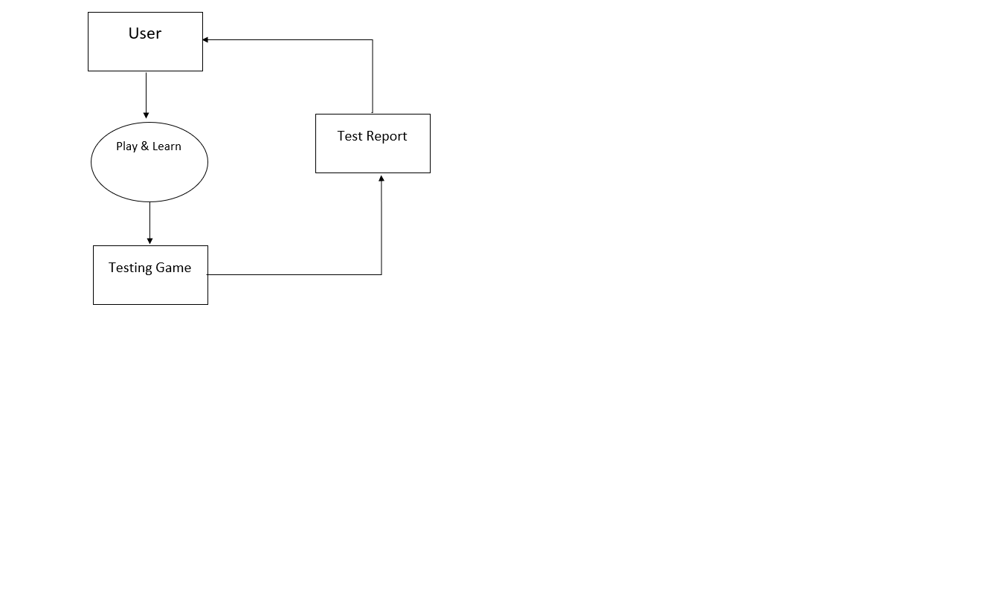

Figure 3: Data Flow Diagram

### Use case Diagram:

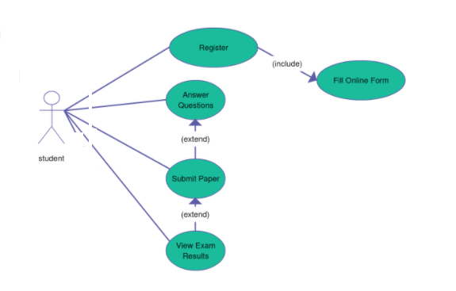

Figure 4: Use case Diagram

### Sequence Diagram:

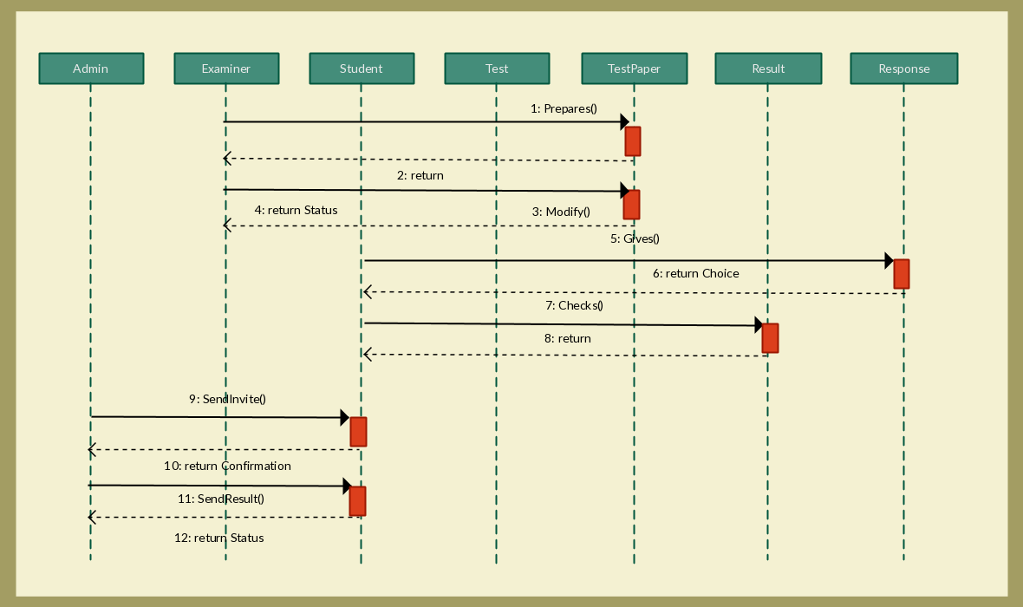

Figure 5: Sequence Diagram

## User Interface:

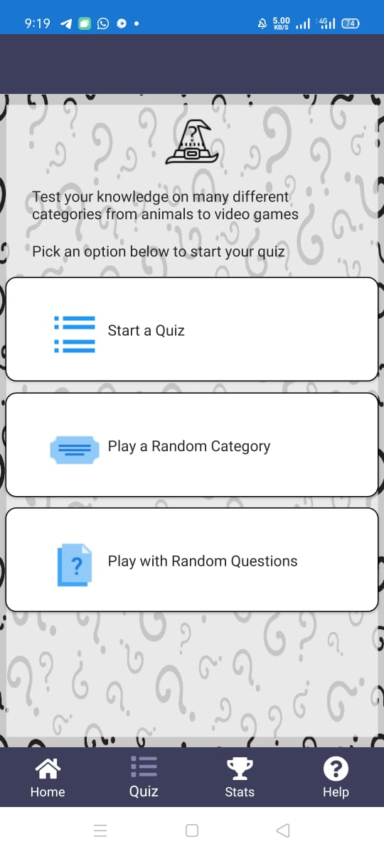

Main dashboard of app

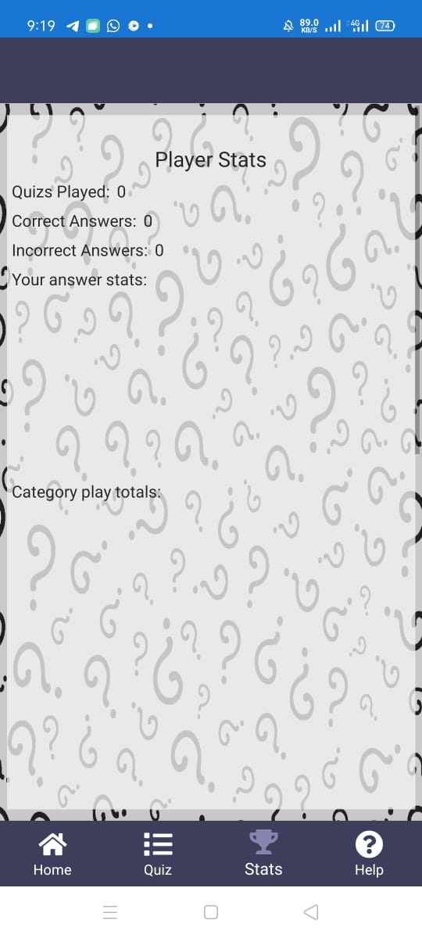

Stats of quiz

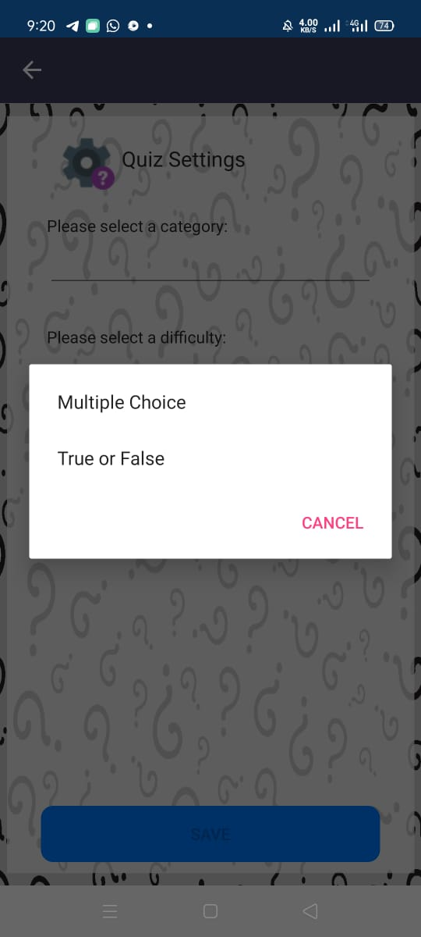

Quiz setting

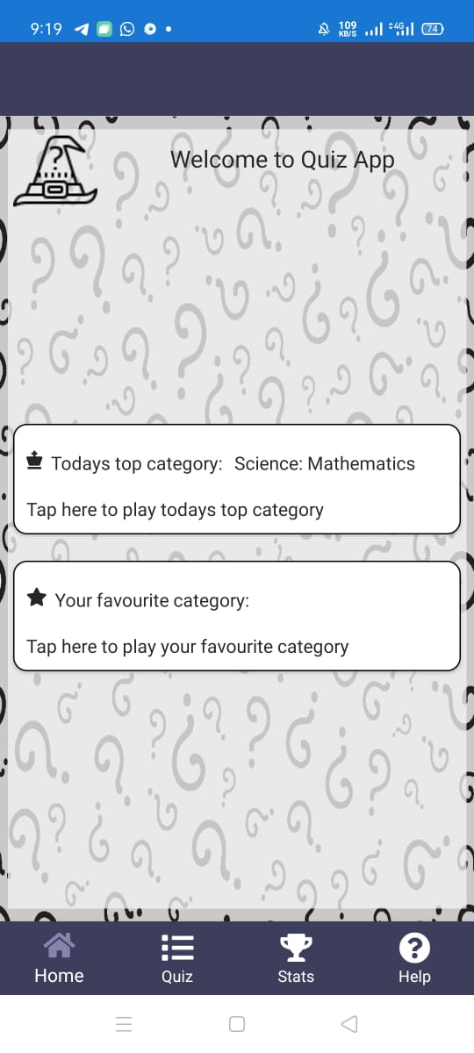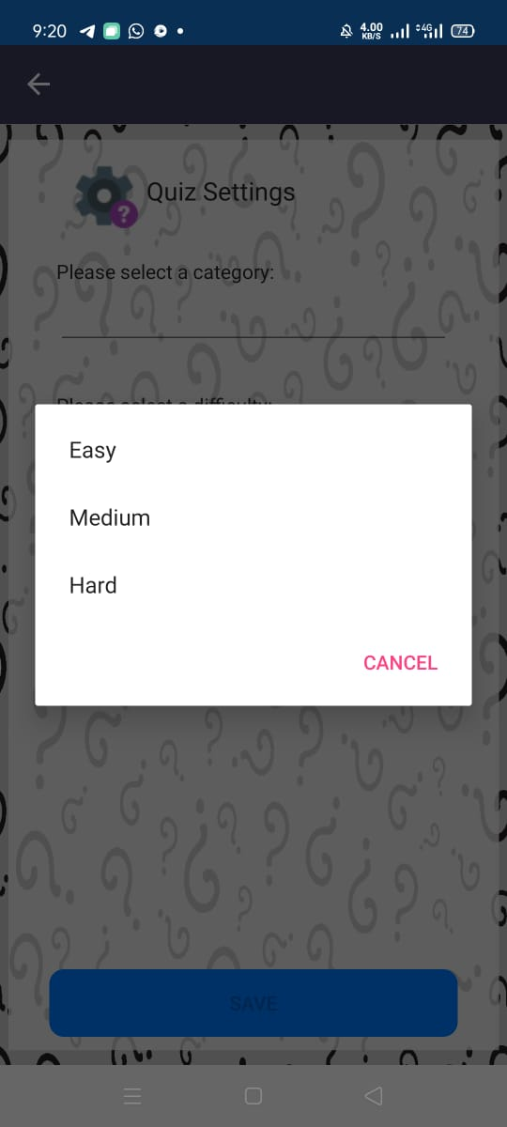

Level setting

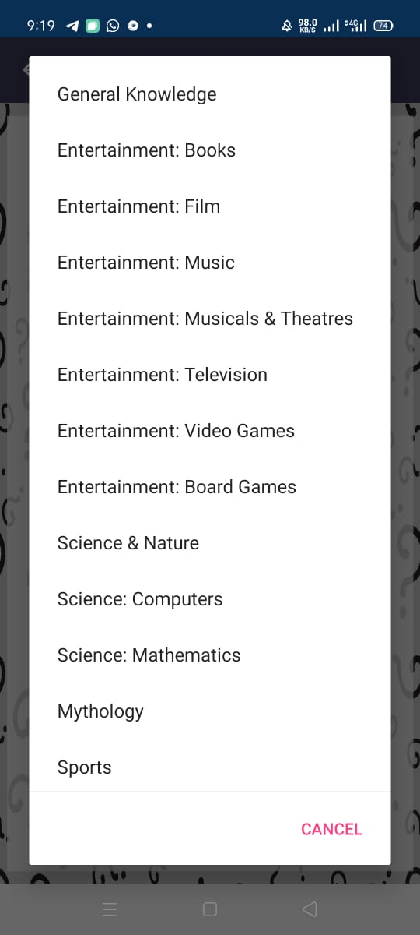

Selection of favourite quiz

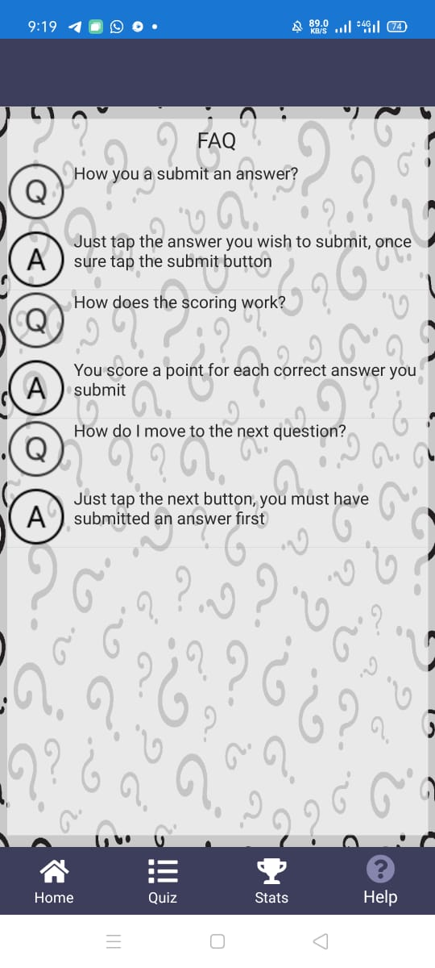

FAQ

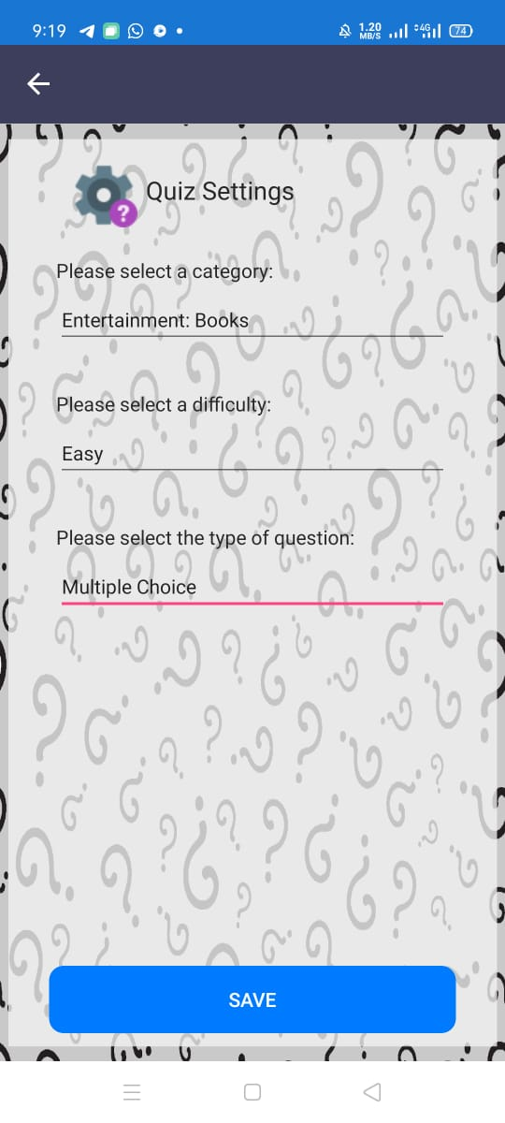

Setting